AI ASSISTED CODING
Name:G.Gouri Shankar
Hall Ticket NO:2303A51012
Batch-01

Lab 2: Exploring Additional AI Coding Tools beyond Copilot – Gemini (Colab)
and Cursor AI
Task 1: Statistical Summary for Survey Data
❖ Scenario:
You are a data analyst intern working with survey responses stored as
numerical lists.
❖ Task:
Use Google Gemini in Colab to generate a Python function that reads a list
of numbers and calculates the mean, minimum, and maximum values.
❖ Expected Output:
➢ Correct Python function
-Yes it is generated by Gemini.
➢ Output shown in Colab
-Yes mean, min, max values are been formed
➢ Screenshot of Gemini prompt and result
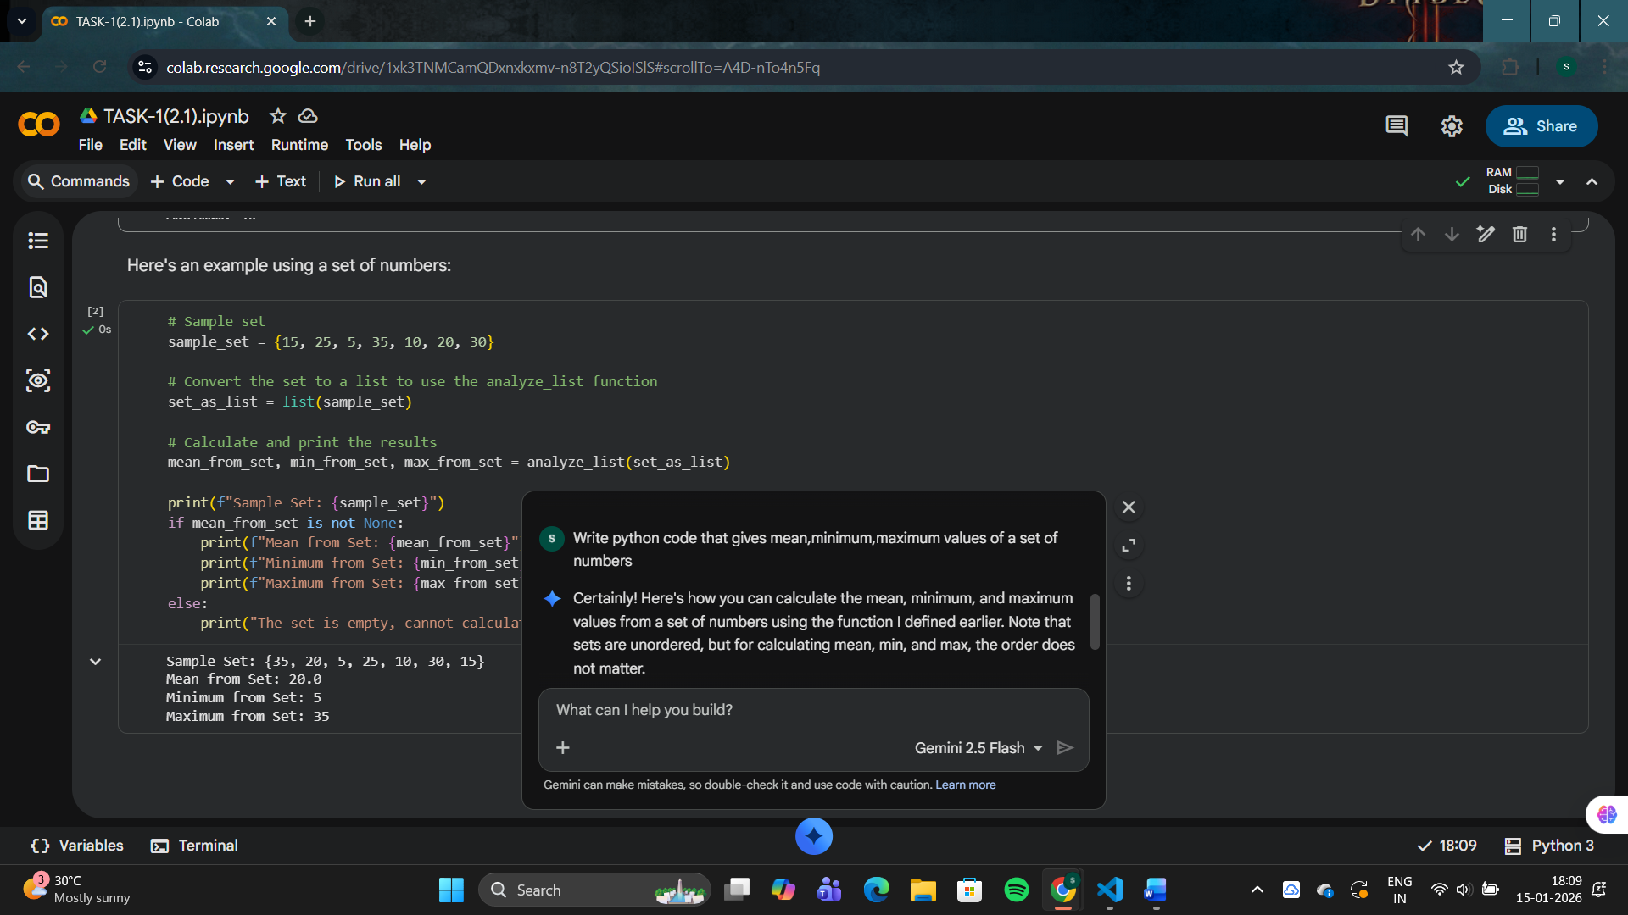
Task 2: Armstrong Number – AI Comparison
❖ Scenario:
You are evaluating AI tools for numeric validation logic.
❖ Task:
Generate an Armstrong number checker using Gemini and GitHub
Copilot.
Compare their outputs, logic style, and clarity.
❖ Expected Output:
➢ Side-by-side comparison table
Feature | Google Gemini | GitHub Copilot
Code Correctness | Correct | Correct
Logic Style | Straightforward, beginner-friendly | Slightly optimized, cleaner variables
Readability | Good | Very good
Comments | Basic comments | Clear inline comments
Ease of Generation | Easy in chat | Very fast while typing
Output | Correct | Correct

➢ Screenshots of prompts and generated code
#Write a Python code to check whether a given number is an Armstrong number. Include comments and print the result.(gemini)
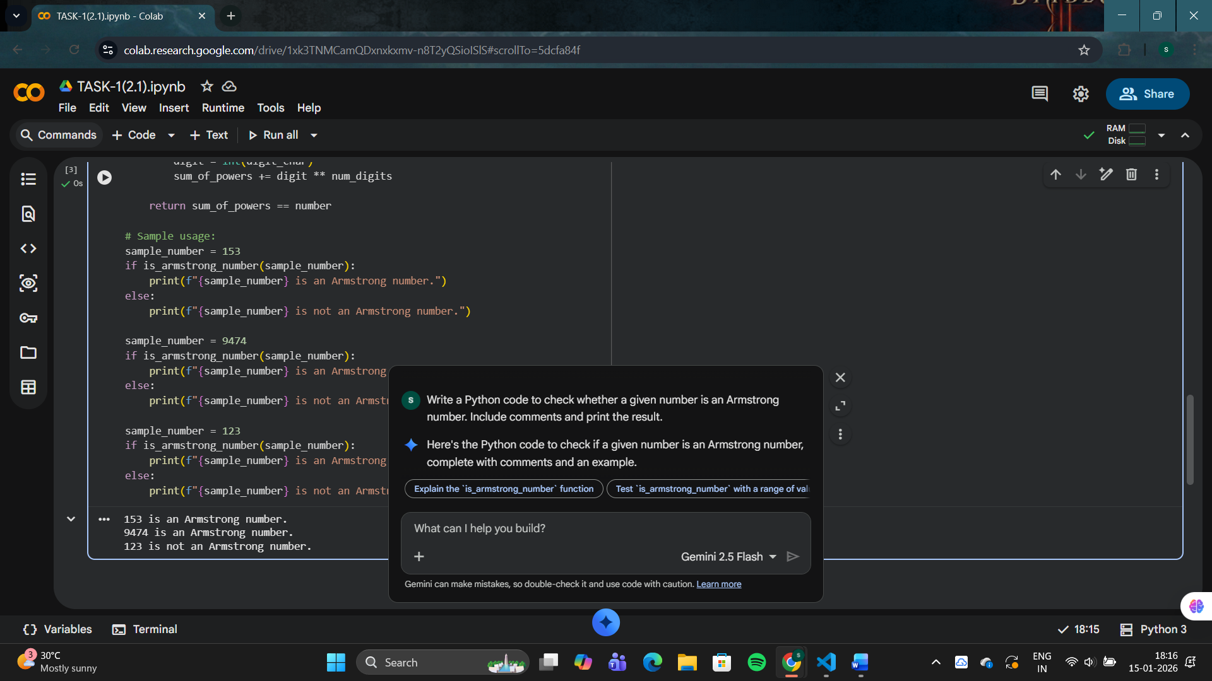
# display a python code to check wheater a number is an Armstrong number or not(gitcopilot)
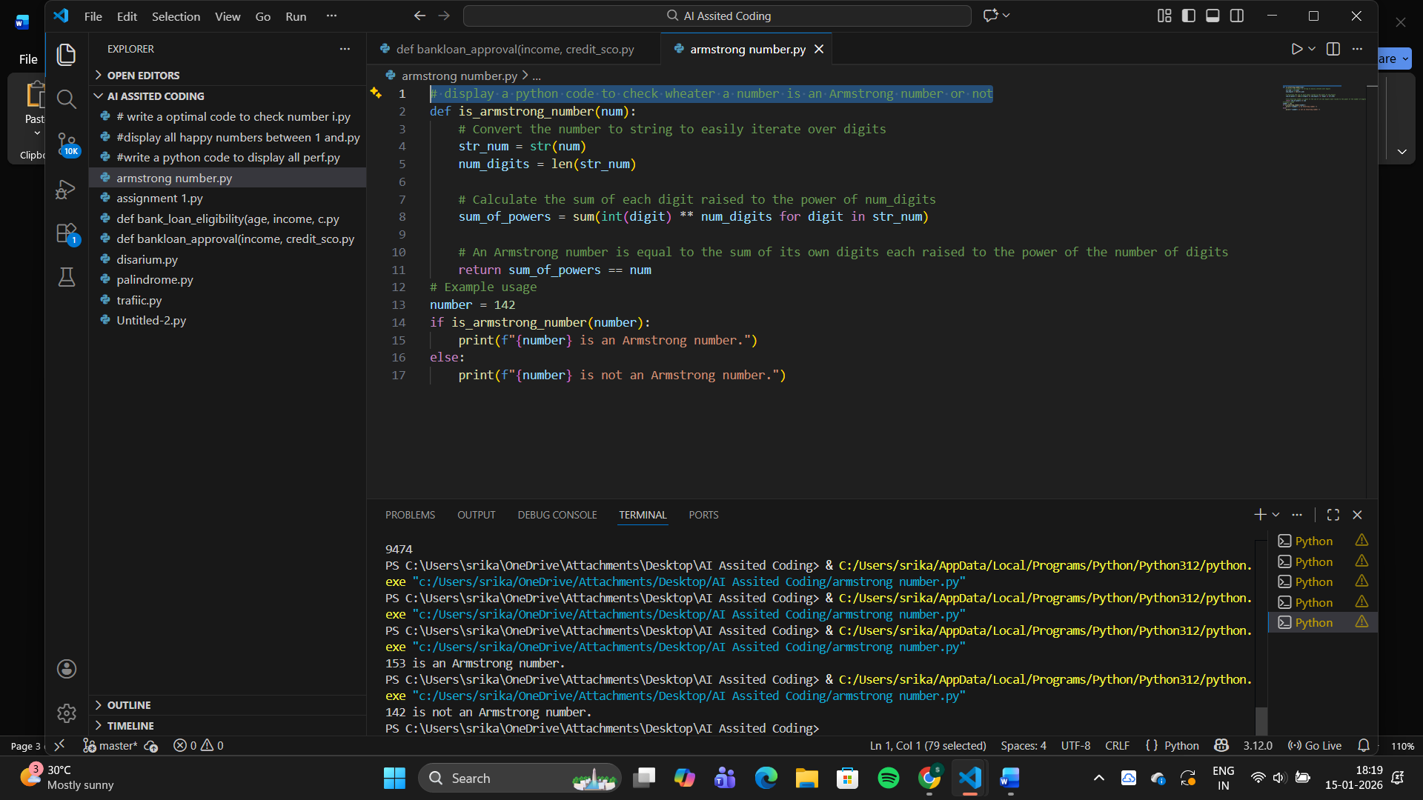
Task 3: Leap Year Validation Using Cursor AI
❖ Scenario:
You are validating a calendar module for a backend system.
❖ Task:
Use Cursor AI to generate a Python program that checks whether a given
year is a leap year.
Use at least two different prompts and observe changes in code.
❖ Expected Output:
➢ Two versions of code
➢ Sample inputs/outputs
➢ Brief comparison
Aspect | Version 1 | Version 2
Prompt Type | Simple | Detailed
Readability | Good | Very Good
Variable Naming | Inline condition | Uses is_leap_year
Comments | Minimal | Clear explanation
Maintainability | Moderate | High
Output | Correct | Correct

# write a python program to check whether a given year is a leap year(cursor)
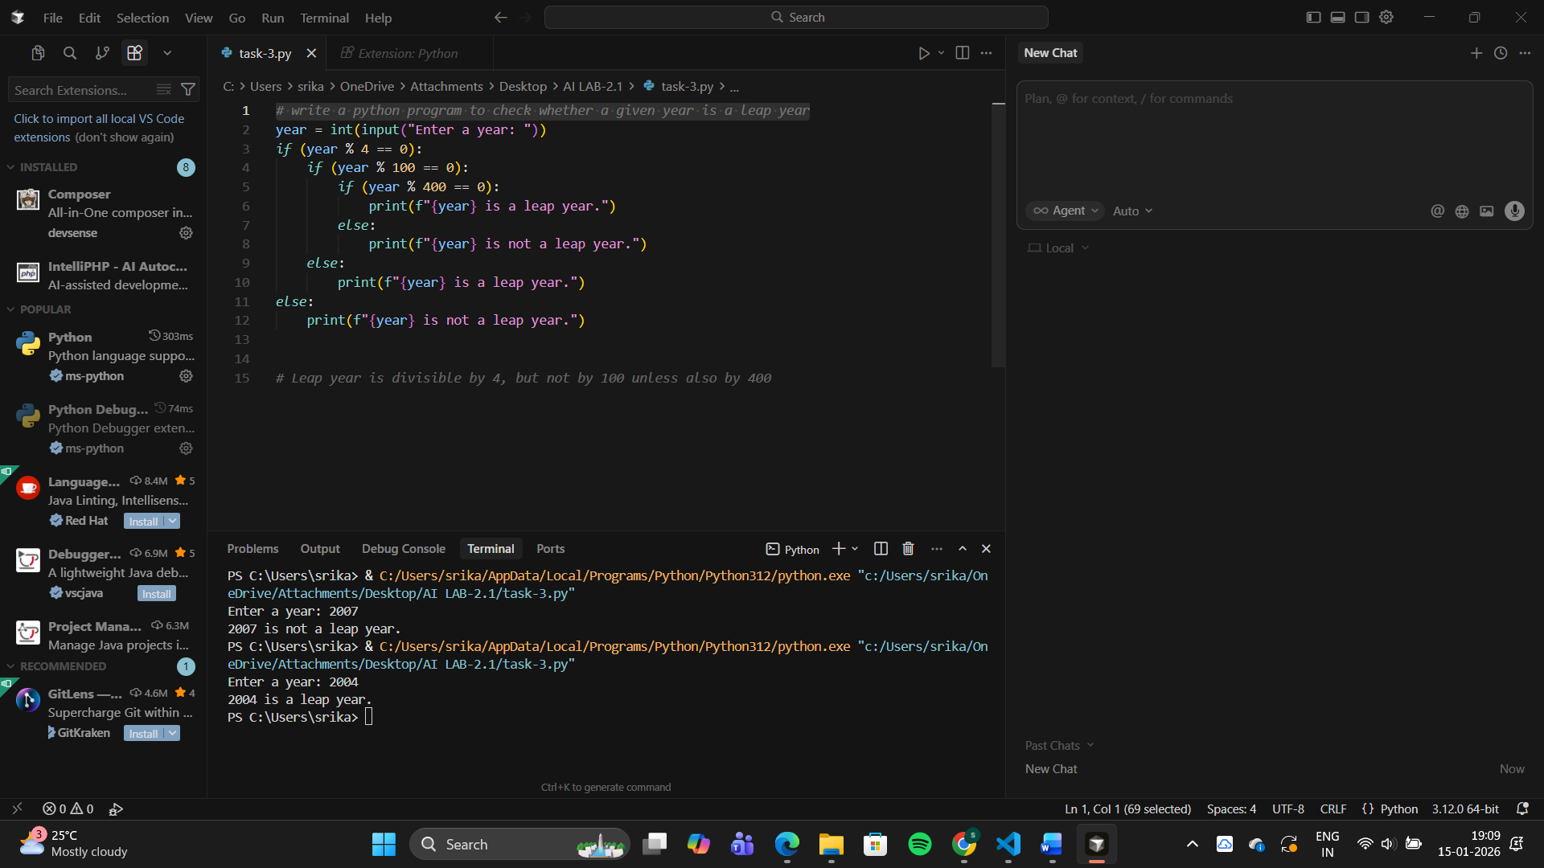
# Python program to validate leap year logic with meaningful variable names and comments
# Function to check if a given year is a leap year using meaningful variable names
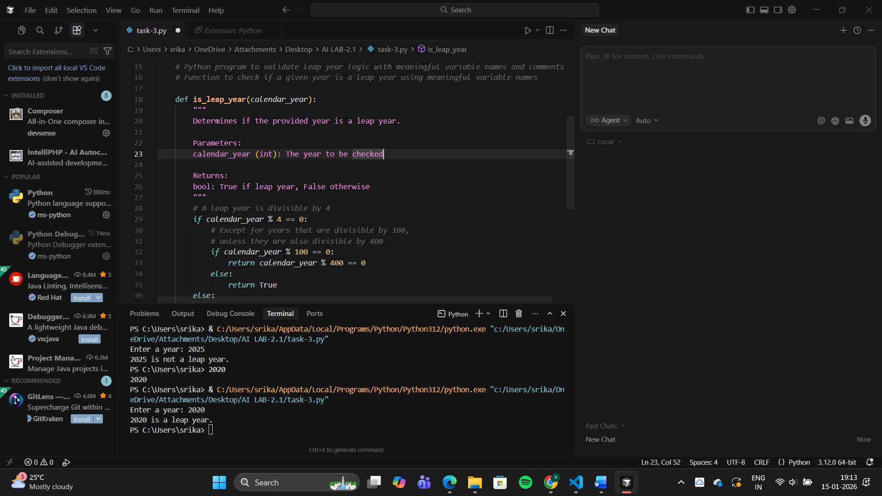
Task 4: Student Logic + AI Refactoring (Odd/Even Sum)
❖ Scenario:
Company policy requires developers to write logic before using AI.
❖ Task:
Write a Python program that calculates the sum of odd and even numbers
in a tuple, then refactor it using any AI tool.
❖ Expected Output:
➢ Original code
#Write a Python program that calculates the sum of odd and even numbers in a tuple, then refactor it using any AI tool.
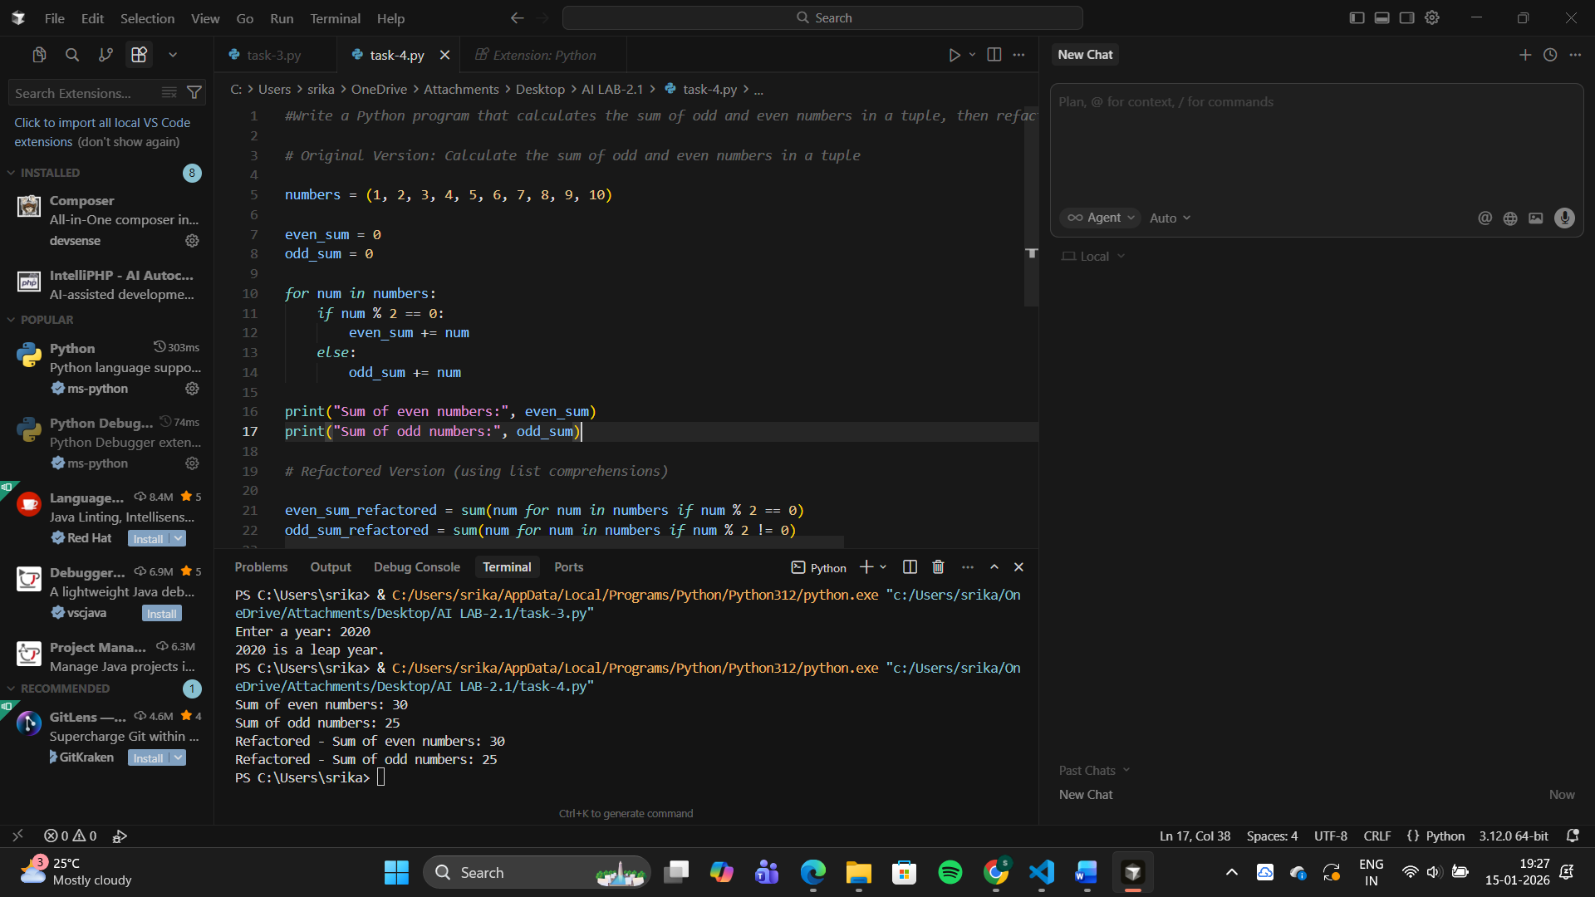
➢ Refactored code
# Refactored Version (using list comprehensions)
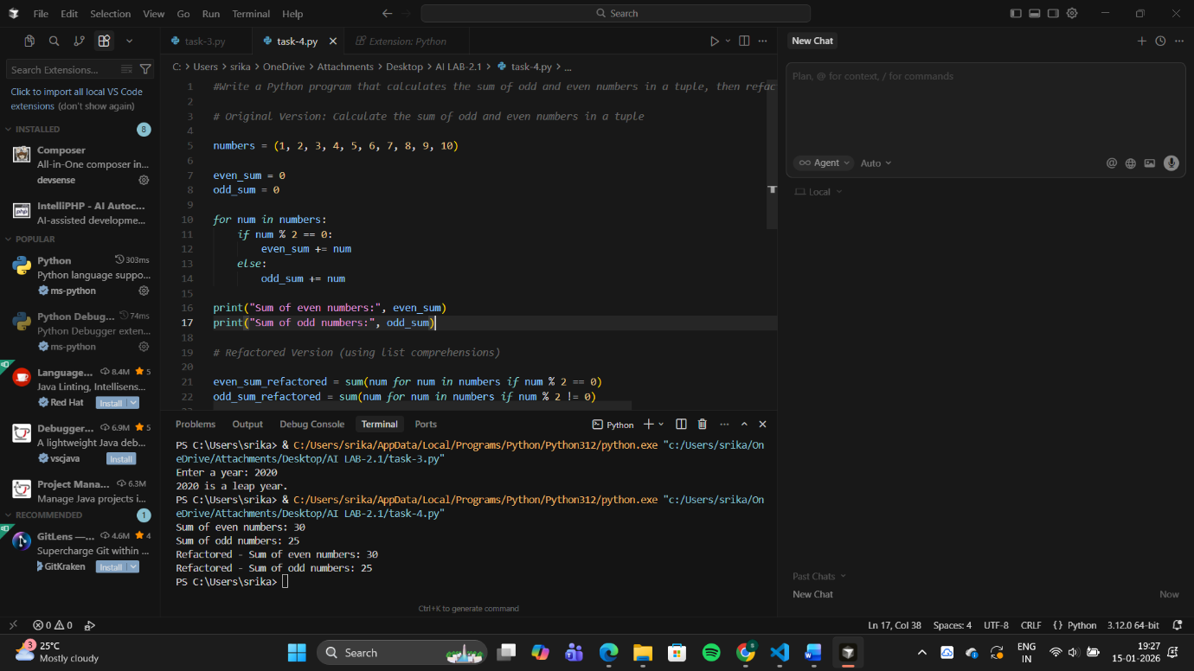
➢ Explanation of improvements
Aspect | Original Code | Refactored Code
Logic Style | Uses explicit loop and condition | Uses Python built-in sum()
Readability | Clear but longer | Shorter and cleaner
Performance | Multiple operations in loop | Optimized with generator expressions
Maintainability | More lines to manage | Easier to modify and review
Code Quality | Basic procedural style | Pythonic and concise

